P.O. Box 683
Duncan, BC V9L 3Y1 Canada
Ph: 828-738-3891
Fax: 828-738-3946
April 19, 2016

the sperling jerry can

“…carrying Living Water in practical ways…”
The rains are here!

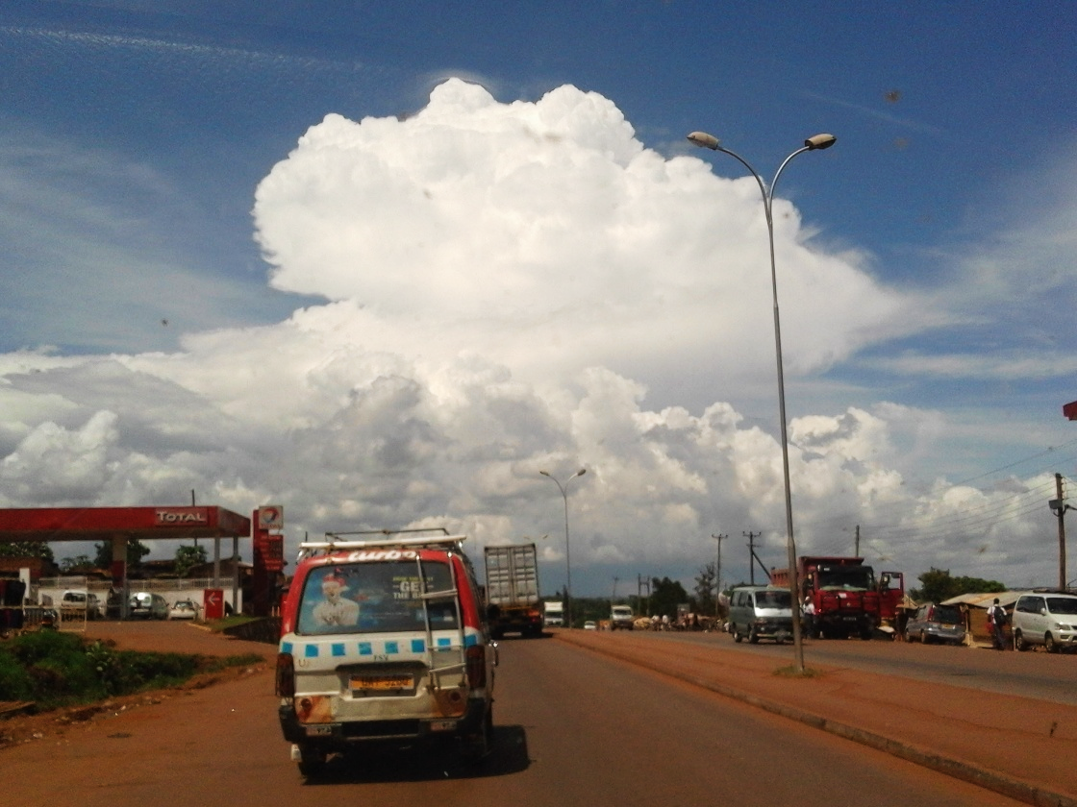
Here in Uganda we don’t have spring to look forward to with all the colourful flowers and fragrant blossoms but we do have the refreshing rains which start around the two Equinoxes. It is now mid-April and we are getting a lot of rain; our first rains were heavy but infrequent. Now we are receiving rain almost every day; this means everything is really green and quite muddy. It also means that our farmers are busy planting and already weeding for the first time. Most of our rain comes in the form of thunderstorms which means that mulching to protect from erosion is a must! It also means that we get a lot of really cool clouds.

Although the rains mean the farmers are very busy it means that I get a break from the busy training season. Since we train mostly in the dry season the rainy season is our chance to get out and visit farmers and to catch up on other work. Some of the other projects going on are our church garden where we are planting vegetables. I have also just planted maize in our Farming God’s Way Kiosk garden at the for the National Agriculture Show here in Jinja. I am also busy planning a number of major events for our Farming God’s Way Uganda Steering Committee; we have a “Young Lions Camp” coming up soon where we are mentoring and building our young and up-coming trainers to be people of integrity and character, then in July we have our national training event in the Capital Kampala. It’s a buys time but I enjoy the variety of garden work along with the planning and farmer follow-up.
Beautiful thunderheads to the east of Jinja
One of the most exciting things to witness here is God using and building His Kingdom through some of my former students. One such man is Joshua Kakande who I taught back in 2010 at Come Let’s Dance in their Farming God’s Way course. It’s so exciting to watch people I’ve trained becoming amazing people of God as they learn to serve Him in faithfulness. Joshua is now doing a number of things related to Farming God’s Way. He has a group of seven pastors here in eastern Uganda that he is training to practice Farming God’s Way; not only is he training them but they are being discipled by him to turn around and be trainers to their communities. Josh has become a mentor both in farming as well as His walk with the Lord.
Six generations

in following God’s ways

The situation with the current farming difficulties here in Uganda have really only one solution; for people to repent of their wickedness and to change their ways. Josh is playing such a key role here. Please keep him in your prayers as he travels a lot and has many looking to him for guidance in their farms and in their lives.
Recently when I went to visit Josh and see how his people are doing we discovered that from Grant Dryden, who taught me, going through Josh and those he has trained we could count 6 generations (transfers) of Farming God’s Way farmers. And not only could we count that many transfers but we could see, down to the sixth generation, the quality of work promoted in the material that Grant has written. God is good to keep hearts after Him and to keep standards high. The result is that He gets the glory.

.With one of the fastest growing populations in the world, in a country the are many. Agriculture remains at the heart of
God’s glory in the garden

in following God’s ways
forward to the chance to guide these young men towards being great servant leaders within the sphere of farming

The boys continue to grow like weeds. Kenny and Andrew can both where my shoes; Kenny is closing in on me in height and the rest can eat like grown men. Feeding them is an ever growing job! The boys love golf and their rugby team, the Jinja Leopards, and of course, kicking the soccer ball around the yard. They are also all doing quite well in school as well, although they are easily distracted from their work.
Family News

in following God’s ways
Alin and Anna are ever growing concerns! Anna is "the designer" -- she loves arranging her food, clothes and toys into patterns. She also enjoys dressing in multiple layers. Alin loves to be involved in everyone else’s lives and loves to check on mommy's new chicks when possible.

As we prepare for home assignment later this year we would love your prayers for wisdom as far as some decisions regarding our kids schooling. The older boys have come to an end of an era with distance learning and homeschooling. Their academic abilities and talents, we feel, need to be developed in a classroom setting. We have a number of options for where they could go to school. Some of them are very expensive and most of them would put them at a considerable distance from us as a family. Would you please pray for wisdom as we look at and consider education options for our older children, Kenny and Albert.
- Ongoing expenses like our salary and ministry costs (mostly related to rural travel and internet costs). Please consider giving monthly and praying for more monthly supporters. If you write monthly checks for the entire year please remember to send them this month to Equip.
Financial Needs:
- Money for a newer vehicle; our current vehicle is becoming old (22 years), small for us (it seats 7 -- we need 10 seats now) and beat up from all the years of banging around the Ugandan roads. Cost:$20,000 (there is about 75% import tax on used vehicles here which obviously makes them very expensive))
- Money for a small plot of land (2 acres) to act as a nearby training site for training local farmers and a money making venture to have some sustainable income here. Cost:$10,000
- Finances for our flights home for furlough next year.
- *To contribute to the Sperling’s needs please see the addresses and links at the end of the letter

Please continue to pray with us in the following areas:
Prayer requests and praises!

- Pray for effectiveness in our ministry; that many will come to know Christ and become His disciple in a manner that glorifies God and His Kingdom.
- Pray for our safety and health with our crazy roads and the many tropical diseases around.
- Pray that God will give us heart’s willing to give sacrificially to those He calls us to.
- Pray for Andrew to make the right choices right now so that he will walk in God’s ways and not the ways of the world which he finds so attractive.
- Pray for peace and safety in Uganda during the upcoming national elections on February 18, 19.
- Pray for provision for the work God has called us to.
- Praise for the slow but steady adoption of Farming God’s Way in Kamuli and Wante and many other parts of Uganda
- Praise for Kezia our new teacher who will help the kids finish off the school year.
- Thanks for all your prayers! They are essential to our life here!

Love, from Chris and Jane, Andrew, Tugume, Kenny, Albert, Isaiah, Ezra, Anna and Alin
E-mail:
sperling_equip@yahoo.ca
In the US donations can be sent to:

Equip, Inc.
PO Box 1126,
Marion, N.C.

USA, 28752-1126
Attach a note “Sperling support”

In Canada donations can be sent to:
Equip Canada
PO Box 683

Duncan, B.C.

V9L 3Y1
Attach a note “Sperling support”

To donate on line go to: www.sperlingsinafrica.com

